REPORT

|  |  |
| --- | --- |
| Date | 10 November 2022 |
| Team ID | PNT2022TMID30903 |
| Project name | Analytics for Hospital Health Data |
| Team members | Abitha s  Bavisni R  Kaviya Dharshini G  Shanmugavel B |

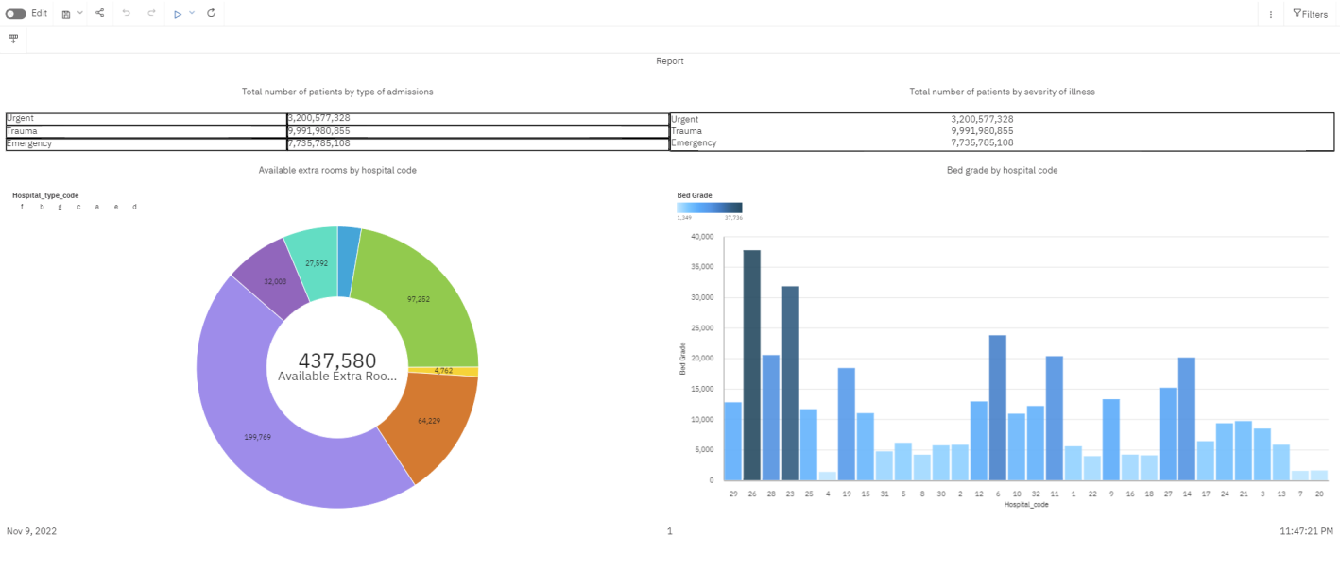

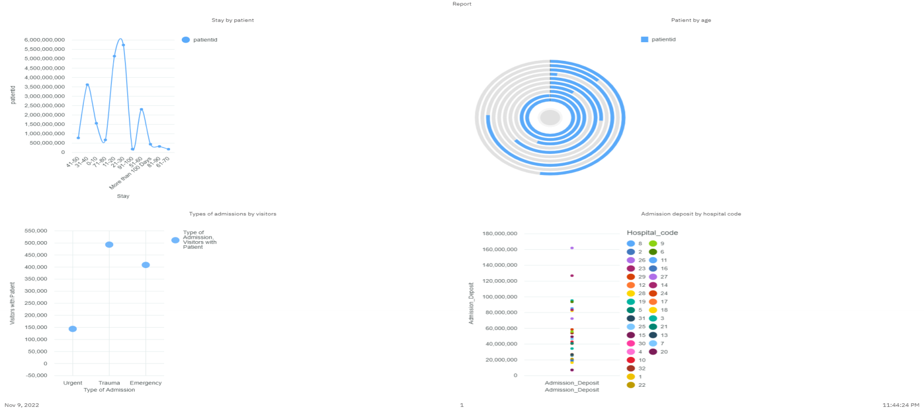

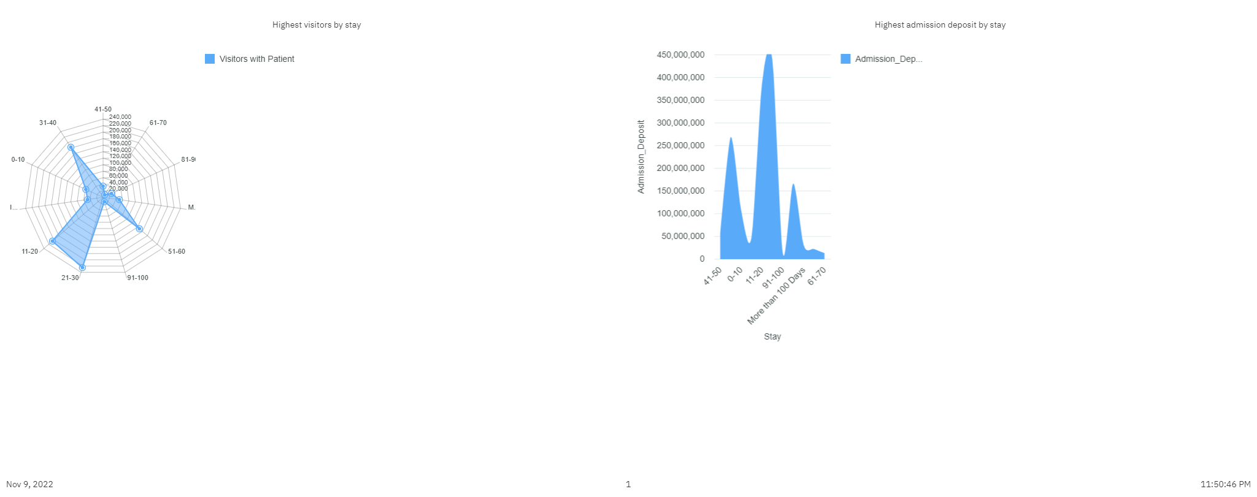

Reference link:

<https://us3.ca.analytics.ibm.com/bi/?perspective=authoring&id=i5B447066C21345EB8F03F569AB388CD7&objRef=i5B447066C21345EB8F03F569AB388CD7&action=run&format=HTML&cmPropStr=%7B%22id%22%3A%22i5B447066C21345EB8F03F569AB388CD7%22%2C%22type%22%3A%22reportView%22%2C%22defaultName%22%3A%22Report%20view%20of%20Report-3%22%2C%22permissions%22%3A%5B%22execute%22%2C%22read%22%2C%22setPolicy%22%2C%22traverse%22%2C%22write%22%5D%7D>